Proposal

We will use data from the County Business Patterns (CBP) Annual Survey from the Census Bureau. The CBP provides annual statistics for businesses with paid employees within the U.S., Puerto Rico, and Island Areas (Guam, American Samoa, the Commonwealth of the Northern Mariana Islands, and the U.S. Virgin Islands) at a detailed geography and industry level. Data for establishments are presented by geographic area, 6-digit NAICS industry, legal form of organization (U.S. and state only), and employment size class. Information is available on the number of establishments, employment during the week of March 12, first quarter payroll, and annual payroll. Precautions are taken to avoid disclosing the operations of an individual employer. We plan on creating a choropleth map that will show data on the county level. There will be at least four drop downs for summary data on state level or on county level, year of data, the industry (NAICS), and the size of the business. When the user hovers over each county (or state), a pop-up will show the values for a few different data fields. We will also have another visualization below that will contrast the political affiliations of the counties (and/or states) and the industry of businesses, # of businesses, and size of businesses in that area. Maybe a bubble visualization like the one in our screenshots. We could make each bubble a

*Reference: https://www.census.gov/programs-surveys/ase/about.html*

Rationale

We decided to go with the route of having a visualization like a choropleth map because we believe it gives the user the best possibility to explore the data themselves, which is the overall goal of the project. Having different filters will allow the user to find trends or lack thereof based off of the variety of filters we will incorporate.

Advanced

Should we have additional time, we will add political data visualization that will show the biggest industries in each state and the states political affiliation.

https://bl.ocks.org/mbostock/4348373

https://bl.ocks.org/mbostock/4342045

Data Set

https://www.census.gov/programs-surveys/ase/data.html

Screenshots

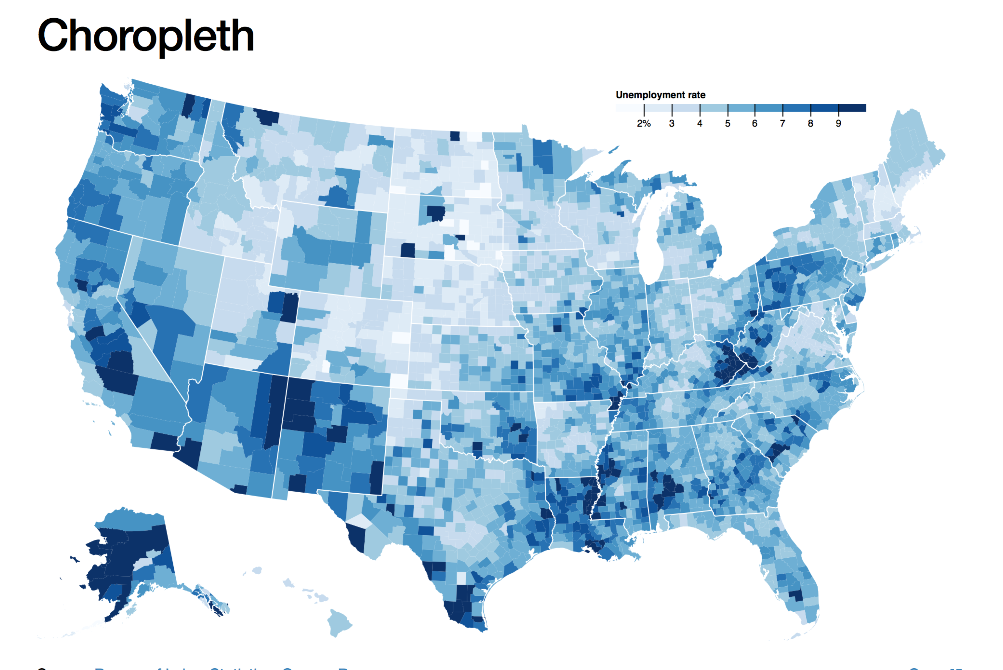

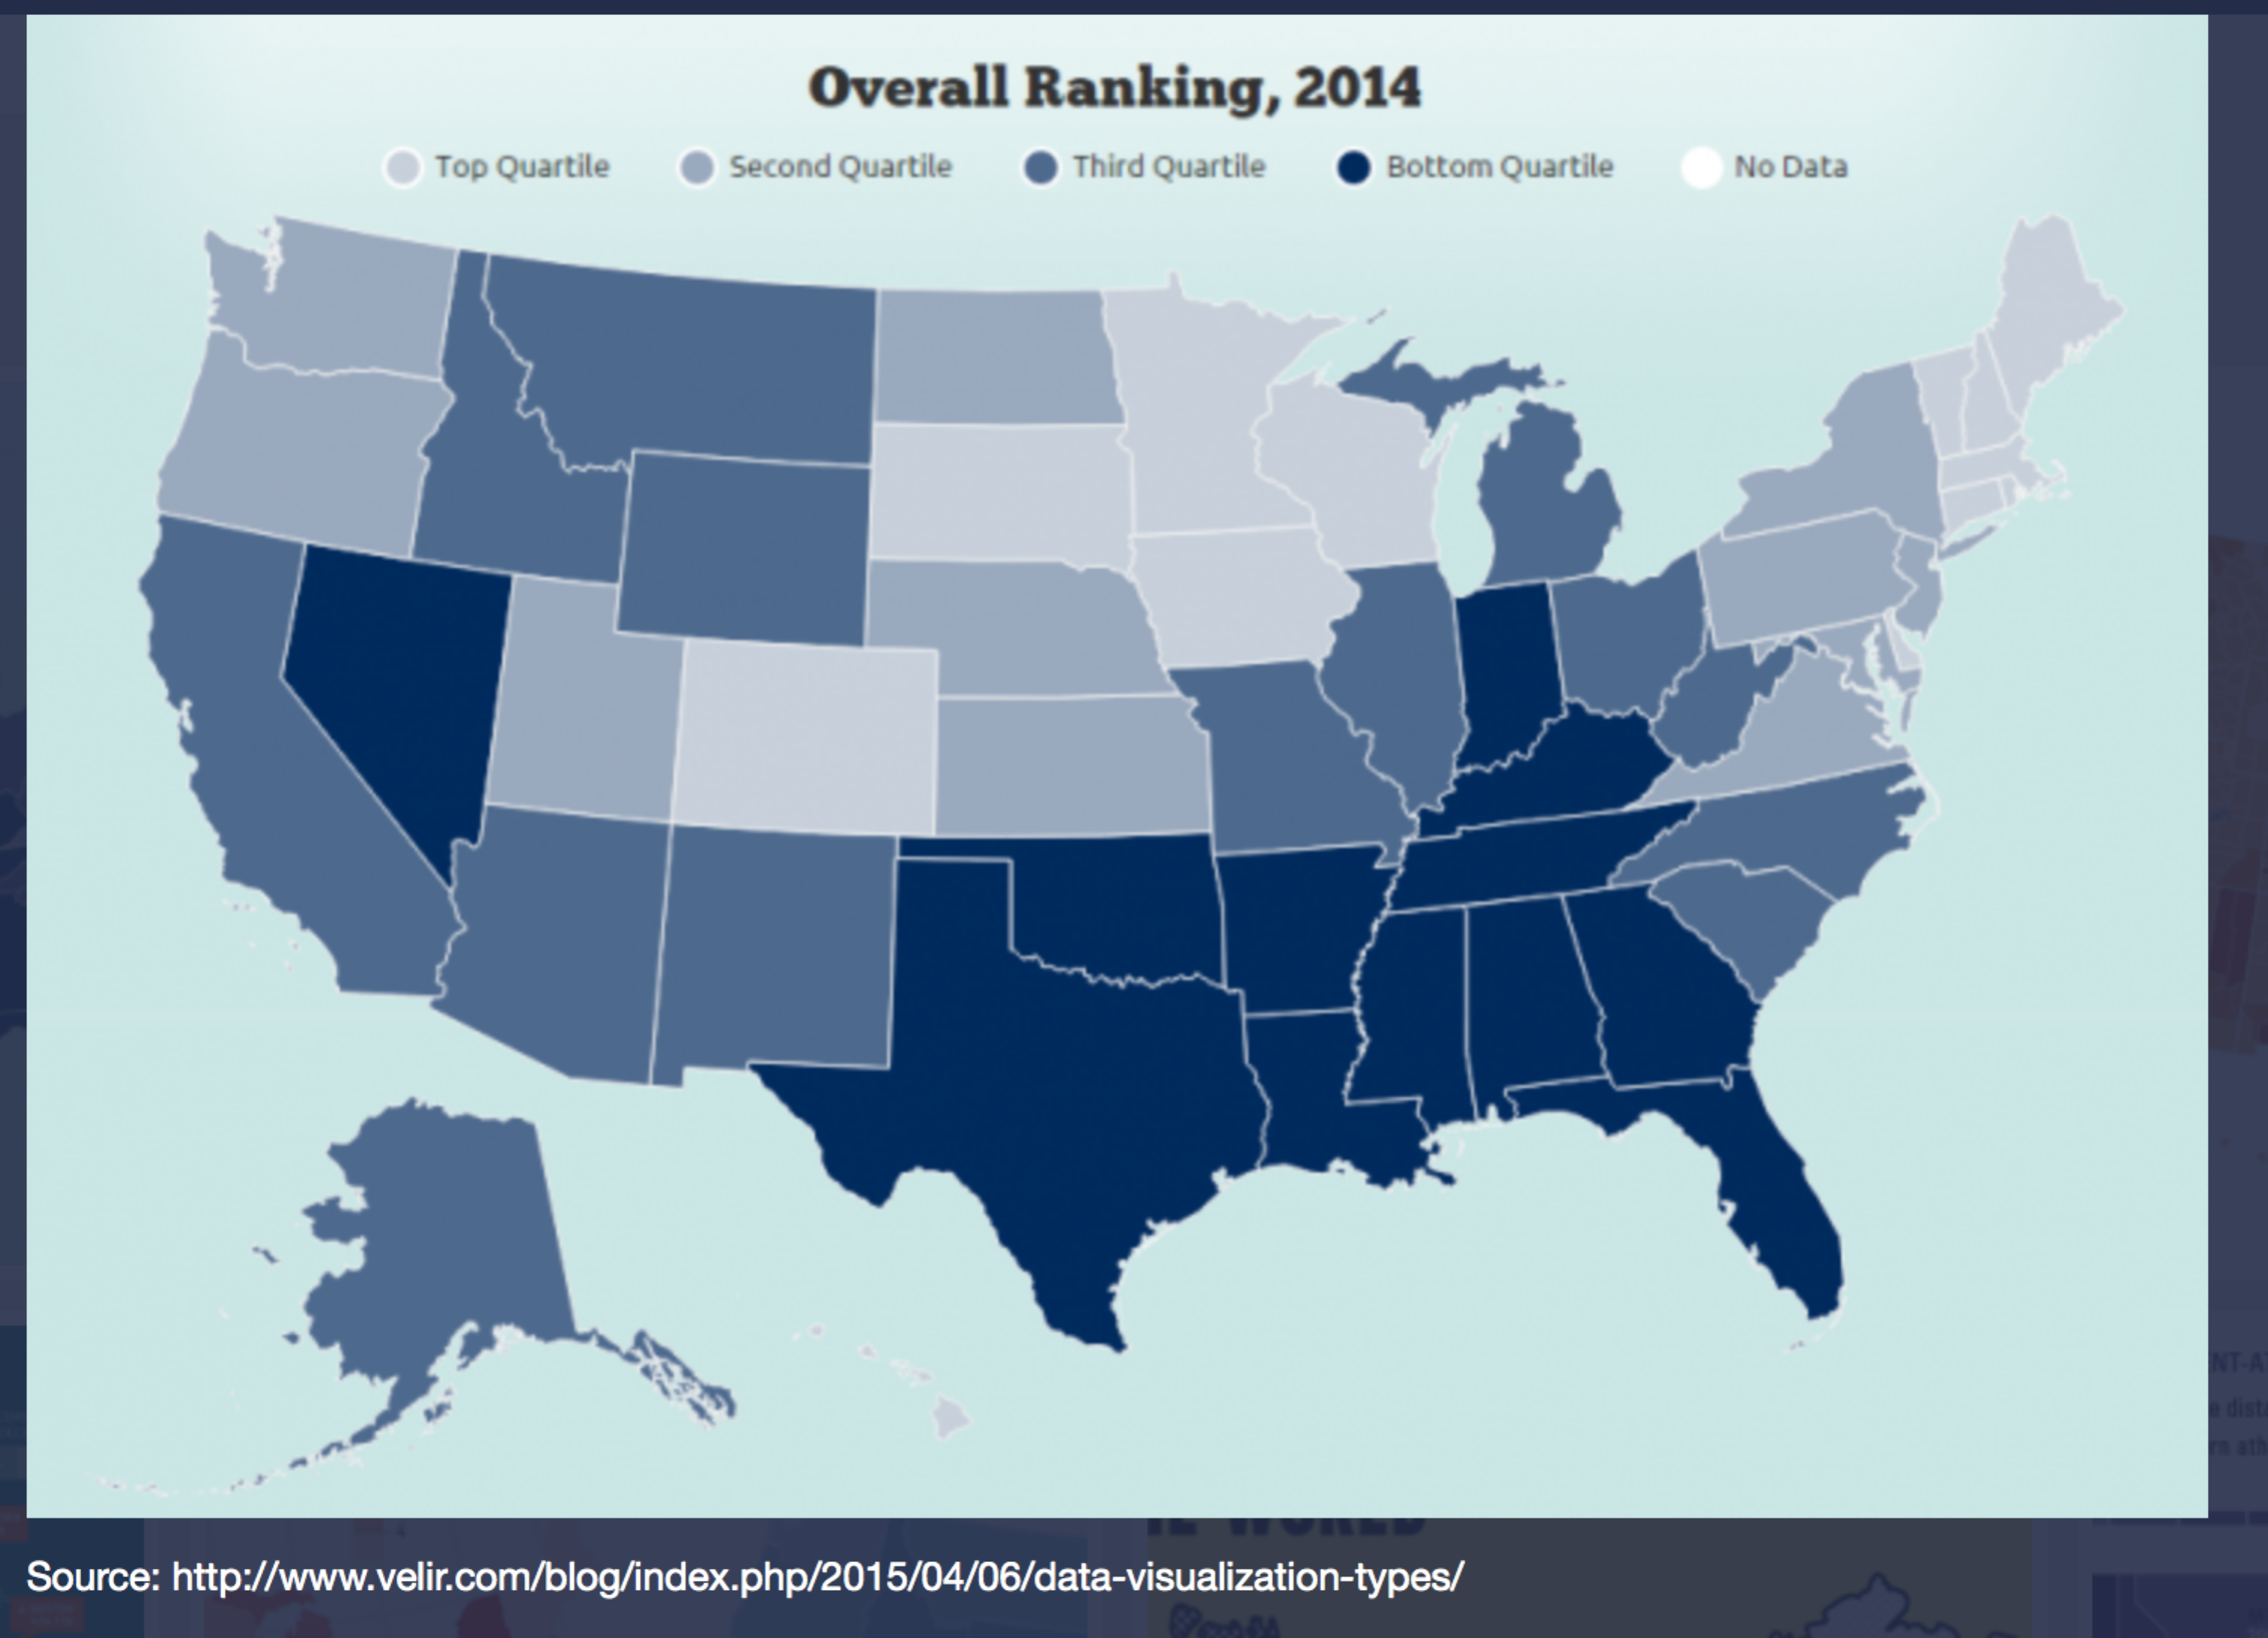

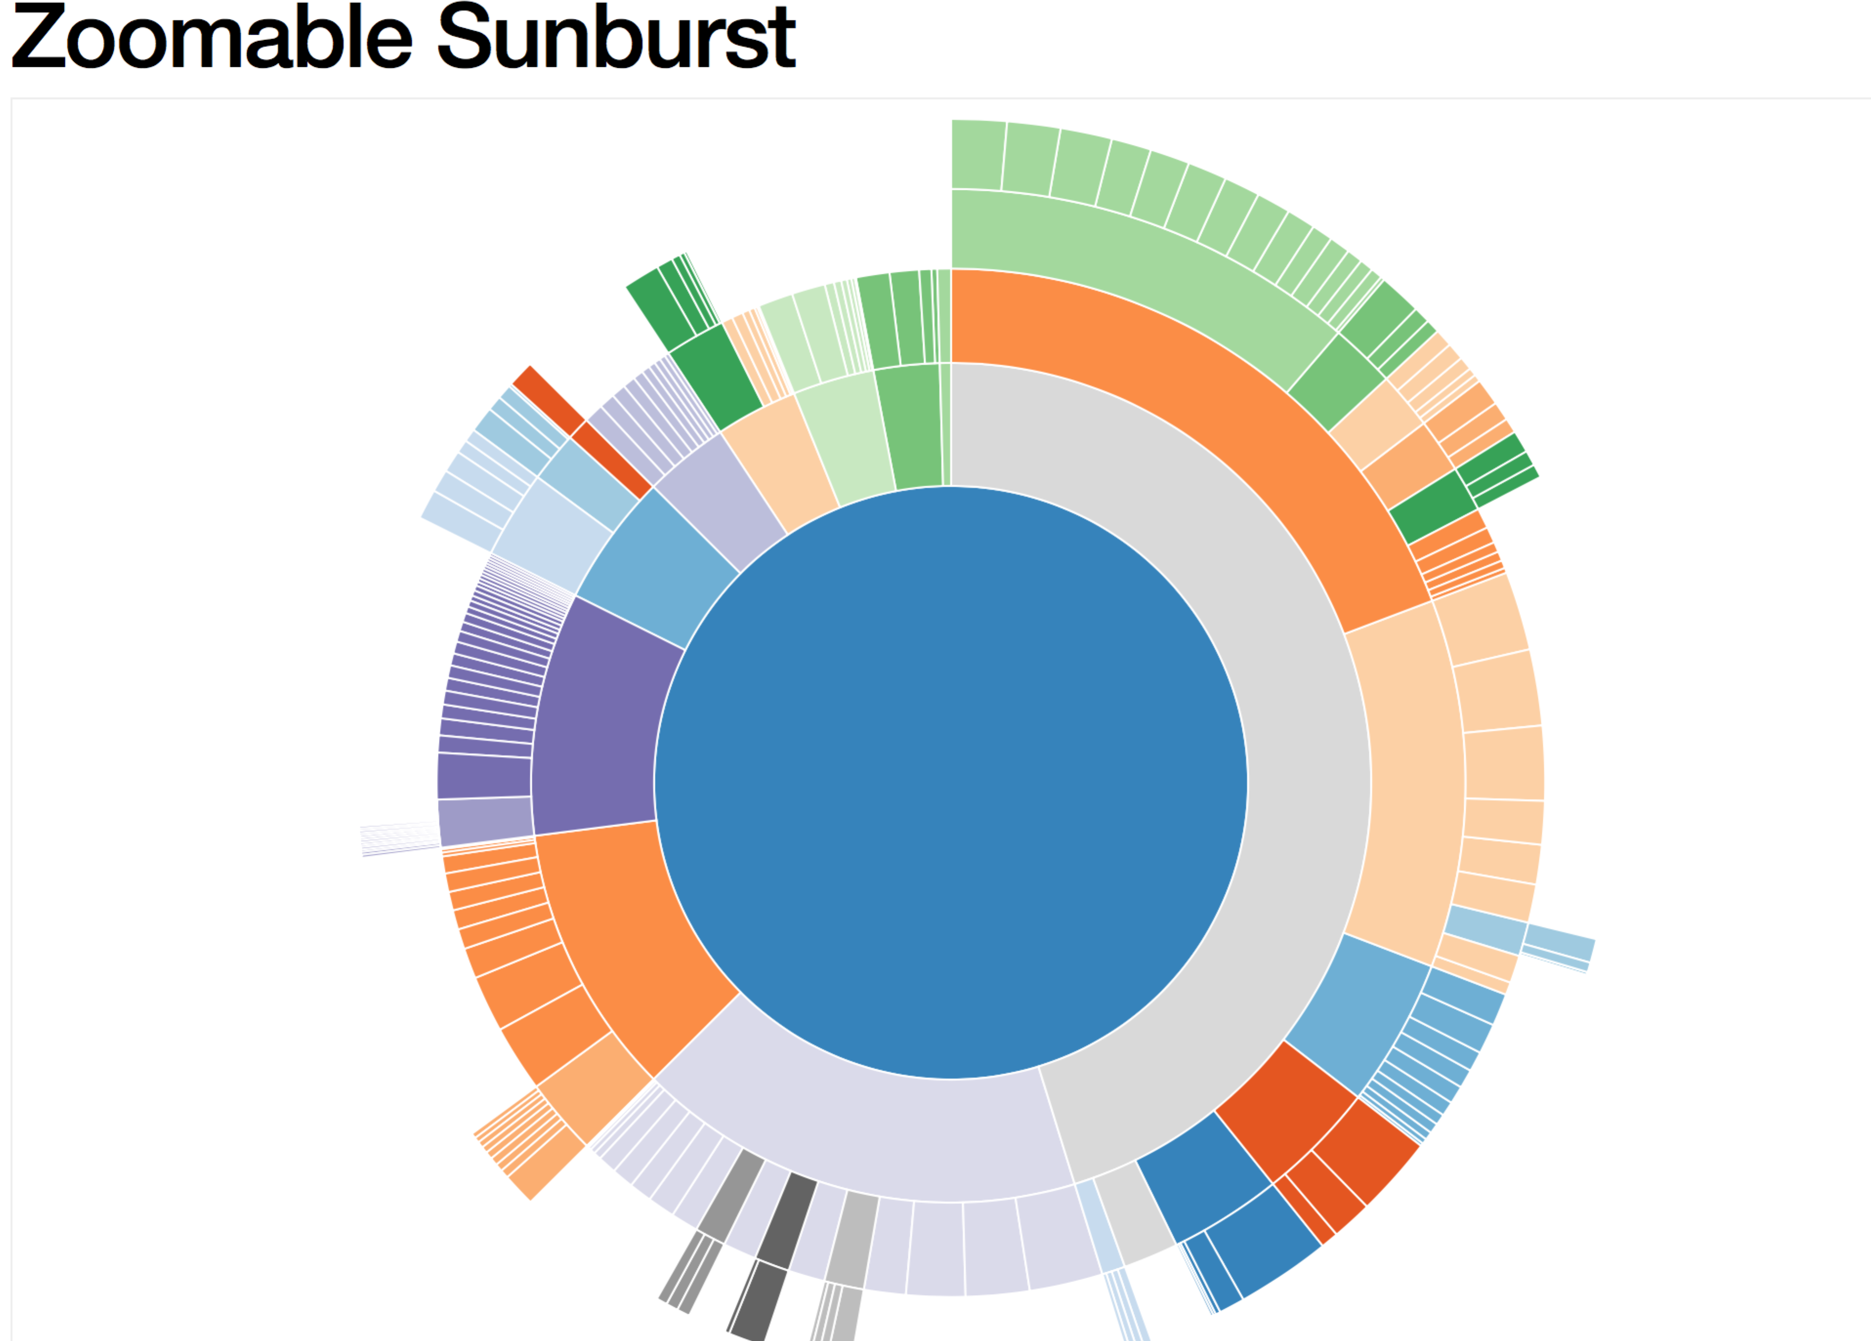

GitHub Repository

https://github.com/roduok/Prjoect-2-Story-Visualtization